

**Vidyavardhini’s**

**College of Engineering & Technology**

Vasai Road (W)

**Department of Computer Engineering**

**Laboratory Manual**

**(Student Copy)**

| Semester | IV | Class | SE |
| --- | --- | --- | --- |
| Course No. | CSL403 | Academic Year | 2023-24 (Even Sem.) |
| Course Name | Operating System Lab | | |



**Vidyavardhini’s College of Engineering & Technology**

**Vision**

To be a premier institution of technical education; always aiming at becoming a valuable resource for industry and society.

**Mission**

* To provide technologically inspiring environment for learning.
* To promote creativity, innovation and professional activities.
* To inculcate ethical and moral values.
* To cater personal, professional and societal needs through quality education.

**Department Vision:**

To evolve as a centre of excellence in the field of Computer Engineering to cater to industrial and societal needs.

**Department Mission:**

* To provide quality technical education with the aid of modern resources.
* Inculcate creative thinking through innovative ideas and project development.
* To encourage life-long learning, leadership skills, entrepreneurship skills with ethical & moral values.

**Program Education Objectives (PEOs):**

PEO1: To facilitate learners with a sound foundation in the mathematical, scientific and engineering fundamentals to accomplish professional excellence and succeed in higher studies in Computer Engineering domain

PEO2: To enable learners to use modern tools effectively to solve real-life problems in the field of Computer Engineering.

PEO3: To equip learners with extensive education necessary to understand the impact of computer technology in a global and social context.

PEO4: To inculcate professional and ethical attitude, leadership qualities, commitment to societal responsibilities and prepare the learners for life-long learning to build up a successful career in Computer Engineering.

**Program Specific Outcomes (PSOs):**

PSO1: Analyze problems and design applications of database, networking, security, web technology, cloud computing, machine learning using mathematical skills, and computational tools.

PSO2: Develop computer-based systems to provide solutions for organizational, societal problems by working in multidisciplinary teams and pursue a career in the IT industry.

**Program Outcomes (POs):**

Engineering Graduates will be able to:

* **PO1. Engineering knowledge:** Apply the knowledge of mathematics, science, engineering fundamentals, and an engineering specialization to the solution of complex engineering problems.
* **PO2. Problem analysis:** Identify, formulate, review research literature, and analyze complex engineering problems reaching substantiated conclusions using first principles of mathematics, natural sciences, and engineering sciences.
* **PO3. Design/development of solutions:** Design solutions for complex engineering problems and design system components or processes that meet the specified needs with appropriate consideration for the public health and safety, and the cultural, societal, and environmental considerations.
* **PO4. Conduct investigations of complex problems:** Use research-based knowledge and research methods including design of experiments, analysis and interpretation of data, and synthesis of the information to provide valid conclusions.
* **PO5. Modern tool usage:** Create, select, and apply appropriate techniques, resources, and modern engineering and IT tools including prediction and modeling to complex engineering activities with an understanding of the limitations.
* **PO6. The engineer and society:** Apply reasoning informed by the contextual knowledge to assess societal, health, safety, legal and cultural issues and the consequent responsibilities relevant to the professional engineering practice.
* **PO7. Environment and sustainability:** Understand the impact of the professional engineering solutions in societal and environmental contexts, and demonstrate the knowledge of, and need for sustainable development.
* **PO8. Ethics:** Apply ethical principles and commit to professional ethics and responsibilities and norms of the engineering practice.
* **PO9. Individual and teamwork:** Function effectively as an individual, and as a member or leader in diverse teams, and in multidisciplinary settings.
* **PO10. Communication:** Communicate effectively on complex engineering activities with the engineering community and with society at large, such as, being able to comprehend and write effective reports and design documentation, make effective presentations, and give and receive clear instructions.
* **PO11. Project management and finance:** Demonstrate knowledge and understanding of the engineering and management principles and apply these to one’s own work, as a member and leader in a team, to manage projects and in multidisciplinary environments.
* **PO12. Life-long learning:** Recognize the need for and have the preparation and ability to engage in independent and life-long learning in the broadest context of technological change.

**Course Objectives**

| 1 | Understand internal, external commands of operating system, Shell scripts and explore various system calls. |
| --- | --- |
| 2 | Implement and analyze process scheduling algorithms. |
| 3 | Implement and analyze deadlock management algorithms. |
| 4 | Implement and analyze memory management algorithms |
| 5 | Implement file allocation strategies. |
| 6 | Implement and analyze disk scheduling algorithms. |

**Course Outcomes**

| At the end of the course student will be able to: | | Action verb | Bloom Level |
| --- | --- | --- | --- |
| CSL403.1 | Use the Linux commands to write Shell scripting program using system calls. | Use | Apply (Level 3) |
| CSL403.2 | Analyze the performance of process scheduling algorithms based on CPU utilization and throughput. | Analyze | Analyze (Level 4) |
| CSL403.3 | Write a program for deadlock detection and avoidance algorithm using C programming language. | Write | Apply (Level 3) |
| CSL403.4 | Analyze the performance of memory management techniques based on space complexity. | Analyze | Analyze (Level 4) |
| CSL403.5 | Analyze the performance of virtual memory management algorithms based on time complexity. | Analyze | Analyze (Level 4) |
| CSL403.6 | Write a program for file management and I/O management techniques using C programming language. | Write | Apply (Level 3) |

**Mapping of Experiments with Course Outcomes**

| Experiment | Course Outcomes | | | | | |
| --- | --- | --- | --- | --- | --- | --- |
| CSL  403.1 | CSL  403.2 | CSL  403.3 | CSL.  403.4 | CSL  403.5 | CSL  403.6 |
| Explore the internal and external commands of Linux. | 3 | - | - | - | - | - |
| Explore User Management commands of Linux. | 3 | - | - | - | - | - |
| Write shell scripts programming. | 3 | - | - | - | - | - |
| Create a child process in Linux using the fork system call. | 2 | 3 | - | - | - | - |
| Explore the system calls used in file operations.. | 1 | - | - | - | - | 2 |
| Implement process scheduling algorithms FCFS and SJF using CPU-OS Simulator. | - | 3 | - | - | - | - |
| Implement deadlock detection and avoidance using Banker’s algorithm. | - | - | 3 | - | - | - |
| Implement memory allocation strategy First fit. | - | - | - | 3 | - | - |
| Implement page replacement policy FIFO. | - | - | - | - | 3 | - |
| Implement disk scheduling algorithm SCAN | - | - | - | - | - | 3 |

Enter correlation level 1, 2 or 3 as defined below

1: Slight (Low) 2: Moderate (Medium) 3: Substatial (High)

If there is no correlation put “—“.

**INDEX**

| **Sr. No.** | **Name of Experiment** | **D.O.P.** | **D.O.C.** | **Page No.** | **Remark** |
| --- | --- | --- | --- | --- | --- |
| 1 | Explore the internal and external commands of Linux. |  |  |  |  |
| 2 | Explore User Management commands of Linux. |  |  |  |  |
| 3 | Write shell scripts programming. |  |  |  |  |
| 4 | Create a child process in Linux using the fork system call. |  |  |  |  |
| 5 | Explore the system calls in Linux. |  |  |  |  |
| 6 | Implement process scheduling algorithms FCFS and SJF using CPU-OS Simulator. |  |  |  |  |
| 7 | Implement deadlock detection and avoidance using Banker’s algorithm. |  |  |  |  |
| 8 | Implement memory allocation strategy First fit. |  |  |  |  |
| 9 | Implement page replacement policy FIFO. |  |  |  |  |
| 10 | Implement disk scheduling algorithms SCAN. |  |  |  |  |

D.O.P: Date of performance

D.O.C : Date of correction

| Experiment No.1 |
| --- |
| Explore the internal and external commands of Linux. |
| Date of Performance: 09/01/24 |
| Date of Submission: 23/01/24 |

**Aim:** Explore the internal and external commands of Linux.

**Objective:** The Linux command is a utility of the Linux operating system. All basic and advanced tasks can be done by executing commands.

**Theory:**

**They are grouped into two categories:**

* **Internal Commands :** Commands which are built into the shell. For all the shell built-in commands, execution of the same is fast in the sense that the shell doesn’t have to search the given path for them in the PATH variable, and also no process needs to be spawned for executing it.  
  Examples: source, cd, fg, etc.
* **External Commands :** Commands which aren’t built into the shell. When an external command has to be executed, the shell looks for its path given in the PATH variable, and also a new process has to be spawned and the command gets executed. They are usually located in /bin or /usr/bin. For example, when you execute the “cat” command, which usually is at /usr/bin, the executable /usr/bin/cat gets executed.  
  Examples: ls, cat etc.

**pwd** : It gives absolute path to your current location i.e. current working directory.

napster@napster-Veriton-Series:~$ pwd

/home/napster

**mkdir:** It creates new directory/ folder.

napster@napster-Veriton-Series:~$ mkdir TRIAL

**cd:** It is used to change directory.

napster@napster-Veriton-Series:~$ cd TRIAL

**cd ..** : To come back to previous directory.

**cd \**  : Return to root directory.

**touch:** To create new files.

napster@napster-Veriton-Series:~/TRIAL$ touch hello.txt

            To verify hello.txt is created or not:

napster@napster-Veriton-Series:~/TRIAL$ ls

Hello.txt

6) **ls:** It lists the contents of files and directories.

napster@napster-Veriton-Series:~/TRIAL$ ls

hello.txt  TRIAL2

**cat :** 1) It can also use to create new file with content as shown below.

cat> hello.txt

hello from Shamika

2) It can also use to append the data into existing file as shown below.

cat>>hello.txt

How are you?

3) It is used to concatenate files.

napster@napster-Veriton-Series:~/TRIAL$ cat hello.txt hi.txt

hello from Shamika

How are you?

Welcome to Os Lab.

**mv:**  To rename a file from source to destination and To move file from one location to other location.

napster@napster-Veriton-Series:~/TRIAL$ mv hi.txt how.txt

**grep:** It searches all text files in the current directory for lines containing “hello”

napster@napster-Veriton-Series:~/TRIAL$ grep hello *.txt

hello from Shamika

**rm:** remove / delete files.

napster@napster-Veriton-Series:~/TRIAL/TRIAL2$ rm how.txt

**date:** Print or set the system date and time ,Display the current time in the given

FORMAT, or set the system date.

**b1@comp:~$ date**

Fri Feb 16 15:43:44 IST 2018

**time:** Displays time of the system.

**free:** Shows amount of RAM  In use.

**echo:** Echoes output on the screen.

**clear:** Clears the screen.

**exit:** Exit from the terminal.

**man :** (man commandname) Gives  description about  the command.

**gedit:** To open text editor.

**ps :**  Report a snapshot of the current processes. ps displays information about a selection of the active processes.

**cal** : Displays a calendar.

**wc** **:** print newline, word, and byte counts for each file, Print newline, word, and byte counts for each FILE, and a total line if more than one FILE is specified.

**chmod** - change file mode bits

chmod changes the file mode bits of each given file according to mode, which can be

either a symbolic representation of changes to make, or an octal number

representing the bit pattern for the new mode bits.

**chown** - change file owner and group

chown changes the user and/or group ownership of each given file. If only an owner (a

user name or numeric user ID) is given, that user is made the owner of each given file, and the files' group is not changed. If the owner is followed by a colon and a group name (or numeric group ID), with no spaces between them, the group ownership of the files is changed as well.

**Output:**

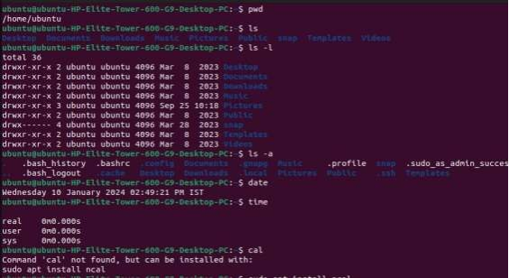

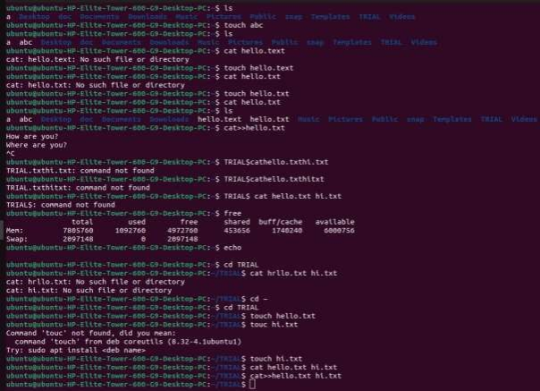

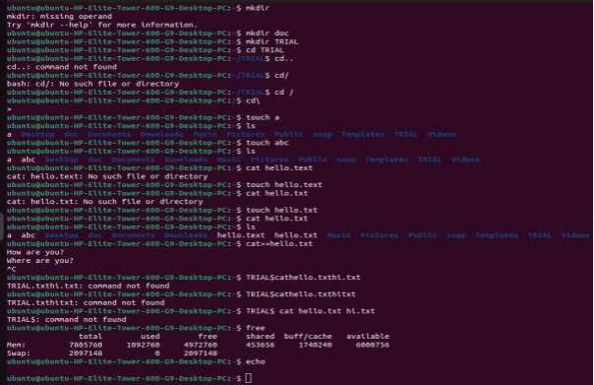

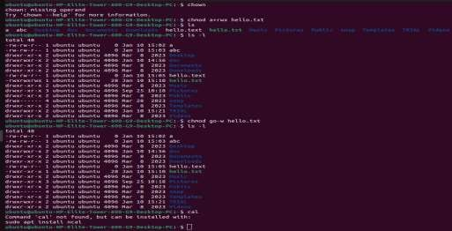

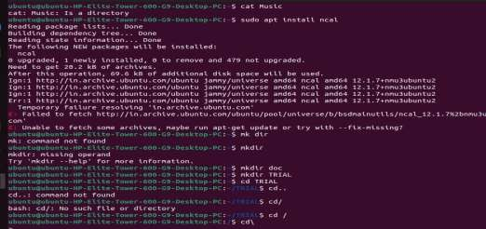

**Conclusion**:

**Command Classification:** Linux commands fall into two categories: internal and external. **Internal Commands**: Built directly into the shell, these commands offer fast execution. The shell doesn't need to search for them or create new processes. Common examples include cd (change directory), source (source a script), and fg (bring a job to foreground).

**External Commands**: These independent programs reside on the disk, typically in directories like /bin or /usr/bin. When you execute an external command, the shell searches for it based on the PATH environment variable and then creates a new process to run the program. Examples include cat (display file contents), ls (list directory contents), and cp (copy files).

| Experiment No. 2 |
| --- |
| Explore User Management commands of Linux. |
| Date of Performance: 23/01/24 |
| Date of Submission: 30/01/24 |

**Aim:** Explore the user management commands of linux.

**Objective:** Since Linux is a multi-user operating system, several people may be logged in and actively working on a given machine at the same time. Security-wise, it is never a good idea to allow users to share the credentials of the same account. In fact, best practices dictate the use of as many user accounts as people needing access to the machine.

At the same time, it is to be expected that two or more users may need to share access to certain system resources, such as directories and files. User and group management in Linux allows us to accomplish both objectives.

**Theory:**

useradd - create a new user or update default new user information ,useradd is a low level utility for adding users.

userdel - delete a user account and related files

groupadd - create a new group , The groupadd command creates a new group account using the values specified on the command line plus the default values from the system. The new group will be entered into the system files as needed.

groupdel - delete a group , The groupdel command modifies the system account files, deleting all

entries that refer to GROUP. The named group must exist

who - show who is logged on , Print information about users who are currently logged in.

whoami - print effective userid

passwd - change user password

The passwd command changes passwords for user accounts. A normal user may only change the password for his/her own account, while the superuser may change the password for any account. passwd also changes the account or associated password validity period.

**Result:**

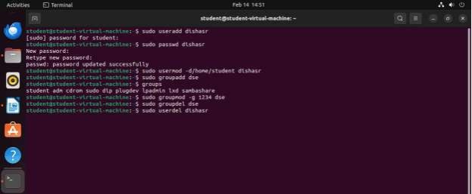

**Conclusion:** By learning how to create, modify, and delete user accounts, we gain practical skills applicable to real-world scenarios.Linux user management commands offer comprehensive capabilities for creating, modifying, and deleting user accounts, managing groups, controlling permissions, and facilitating resource sharing. By effectively utilizing these commands, administrators can maintain a secure and efficient multi-user environment.

| Experiment No.3 |
| --- |
| Write shell scripts programming. |
| Date of Performance: 23/01/24 |
| Date of Submission: 30/01/24 |

**Aim:** Write Shell Scripts to do the following:

1. Perform the basic arithmetic operations

2. Display top 10 processes in Ascending order.

3. Display processes with highest memory usage.

4. Display current logged in user and log name.

5. Display current shell, home directory, kernel version.

**Objective:** The shell is the operating system's command-line interface (CLI) and interpreter for the set of commands that are used to communicate with the system. A shell script is usually created for command sequences in which a user has a need to use repeatedly in order to save time.

**Theory:**

Shell is a user program or its environment is provided for user interaction. It is a command prompt within Linux where you can type commands. It is a program that takes your commands from the keyboard and gives them to the OS to perform. Shell is not part of system KERNAL but it uses system KERNAL to execute programs, create files,etc. A Shell Script is a text file that contains a sequence of commands for a UNIX based OS. It is called a Shell Script because it combines into a "Script" in a single file a sequence of commands, that would otherwise have to be presented to the system from a keyboard one at a time. A Shell Script is usually created for command sequences for which a user has a repeated need. You initiate the sequence of commands in Shell Script by simply entering the name of the Shell Script on a command line.

**Types of Shell Script :-**

* **sh** - Simple Shell
* **bash** - Bourne Again Shell
* **ksh** - Korne Shell
* **csh** - C Shell
* **ssh** - Secure Shell

To use a particular Shell type the Shell name at the command prompt. Eg:- $csh - It will switch the current Shell to C Shell. To view the current Shell that is being used, type echo $ SHELL at the command prompt.

**Output:**

**1. Perform the basic arithmetic operations**

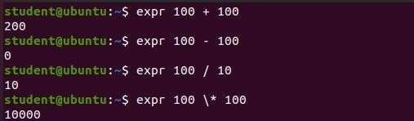

**2. Display top 10 processes in Ascending order.**

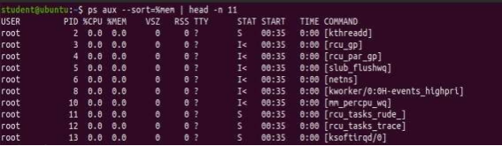

**3. Display processes with highest memory usage.**

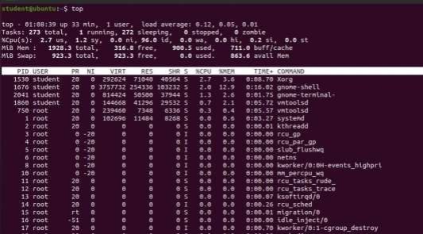

**4. Display current logged in user and log name.**

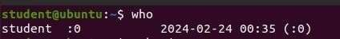

**5. Display current shell, home directory, kernel version.**

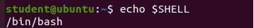



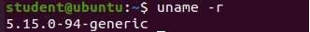

**Conclusion:** In conclusion, the shell scripts provided above demonstrate the versatility and power of shell scripting in Unix-like operating systems. They allow users (us) to perform arithmetic operations, manage processes, and retrieve system information with ease.

| Experiment No.4 |
| --- |
| Create a child process in Linux using the fork system call. |
| Date of Performance: 30/01/24 |
| Date of Submission: 06/02/24 |

**Aim:** Create a child process in Linux using the fork system call. From the child process obtain the process ID of both child and parent by using getpid and getppid system call.

**Objective:** The purpose of fork() is to create a new process, which becomes the child process of the caller. After a new child process is created, both processes will execute the next instruction following the fork() system call.

**Theory:**

A system call is the programmatic way in which a [computer program](https://en.wikipedia.org/wiki/Computer_program) requests a service from the [kernel](https://en.wikipedia.org/wiki/Kernel_(computing)) of the [operating system](https://en.wikipedia.org/wiki/Operating_system) it is executed on. This may include hardware-related services (for example, accessing a [hard disk drive](https://en.wikipedia.org/wiki/Hard_disk_drive)), creation and execution of new [processes](https://en.wikipedia.org/wiki/Process_(computing)), and communication with integral [kernel services](https://en.wikipedia.org/wiki/Kernel_service) such as [process scheduling](https://en.wikipedia.org/wiki/Process_scheduling). System calls provide an essential interface between a process and the operating system.

System call **fork()** is used to create processes. It takes no arguments and returns a process ID. The purpose of **fork()** is to create a **new** process, which becomes the child process of the caller.

* If **fork()** returns a negative value, the creation of a child process was unsuccessful.
* **fork()** returns a zero to the newly created child process.
* **fork()** returns a positive value, the **process ID** of the child process, to the parent. The returned process ID is of type **pid_t** defined in **sys/types.h**. Normally, the process ID is an integer. Moreover, a process can use function **getpid()** to retrieve the process ID assigned to this process.

If the call to **fork()** is executed successfully, Unix will make two identical copies of address spaces, one for the parent and the other for the child.

**getpid, getppid - get process identification**

* **getpid()** returns the process ID (PID) of the calling process. This is often used by routines that generate unique temporary filenames.
* **getppid()** returns the process ID of the parent of the calling process. This will be either the ID of the process that created this process using fork().

**Code:**

#include <stdio.h>

#include <sys/types.h>

#include <unistd.h>

#include <fcntl.h>

int main() {

pid_t p, p1, p2;

int num1 = 10, num2 = 20, num3 = 15; int largest, smallest;

// Find largest number

if (num1 >= num2 && num1 >= num3) largest = num1;

else if (num2 >= num1 && num2 >= num3) largest = num2;

else

largest = num3;

// Find smallest number

if (num1 <= num2 && num1 <= num3) smallest = num1;

else if (num2 <= num1 && num2 <= num3) smallest = num2;

else

smallest = num3;

printf("The largest number is %d\n", largest);

printf("The smallest number is %d\n", smallest); fork();

fork();

fork();

p = getpid(); p1 = getppid();

printf("Current process id is %d and its parent id is %d \n", p, p1); p2 = getuid();

printf("The real user id of the calling process is %d \n", p2); p2 = geteuid();

printf("The effective user id of the calling process is %d \n", p2); p2 = getgid();

printf("The real group id of the calling process is %d \n", p2); p2 = getegid();

printf("The effective group id of the calling process is %d \n", p2); int fd;

char buffer[80];

static char message[ ] = "Comparison done"; fd = open("abc.txt", O_RDWR);

if (fd != -1) {

printf("abc.txt opened with read/write access \n"); write(fd, message, sizeof(message));

lseek(fd, 0, 0);

read(fd, buffer, sizeof(message));

printf("%s - was written to abc.txt\n", buffer); close(fd);

} else {

printf("Failed to open abc.txt\n");

}

return 0;

}

**Output:**

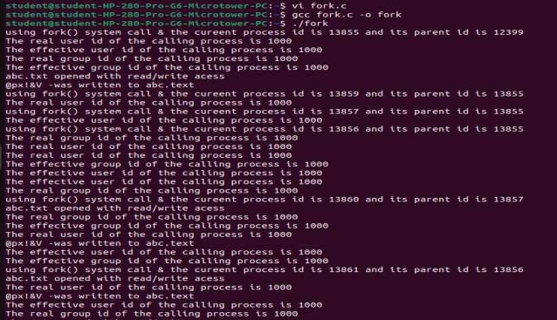

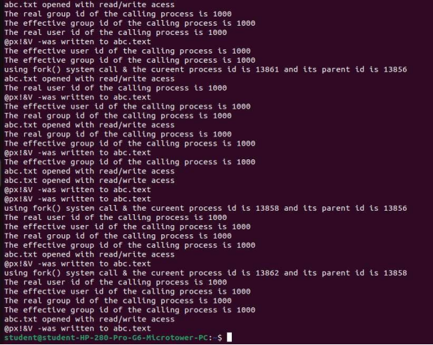

**Conclusion:** In Unix-like operating systems, the `fork()` system function duplicates the current process to start a new one. It is utilized for concurrency, isolation, parallel processing, parallel execution, and process formation. Programs may execute tasks concurrently thanks to `fork()}, effectively splitting workloads. It makes it possible to build concurrent and multitasking processes, each with its own memory and resources. Furthermore, `fork()} is necessary for networking applications that leverage forking servers and the creation of background processes.

| Experiment No.5 |
| --- |
| Explore the system calls in Linux. |
| Date of Performance: 06/02/24 |
| Date of Submission: 13/02/24 |

**Aim:**  Explore the system calls open, read, write, close, getuid, getgid, getegid, geteuid of

Linux.

**Objective:** When a program in user mode requires access to RAM or a hardware resource, it must ask the kernel to provide access to that resource. This is done via a system call.

**Theory:**

**getuid, geteuid** - get user identity

**getgid, getegid** - get group identity

* **getuid**() returns the real user ID of the calling process.
* **geteuid**() returns the effective user ID of the calling process.
* **getgid()** returns the real group ID of the calling process.
* **getegid()** returns the effective group ID of the calling process.

All four functions shall always be successful and no return value is reserved to indicate an error.

[Unix-like](https://en.wikipedia.org/wiki/Unix-like) operating systems identify a user within the [kernel](https://en.wikipedia.org/wiki/Kernel_(computing)) by a value called a **user identifier**, often abbreviated to **user ID** or **UID**. The UID, along with the [group identifier](https://en.wikipedia.org/wiki/Group_identifier) (GID) and other access control criteria, is used to determine which system resources a user can access.

**Effective user ID**

The effective UID (euid) of a process is used for most access checks. It is also used as the owner for files created by that process. The effective GID (egid) of a process also affects access control and may also affect file creation, depending on the semantics of the specific kernel implementation in use and possibly the mount options used.

**Open**: Used to Open the file for reading, writing or both. Open() returns file descriptor **3** because when main process created, then fd **0, 1, 2** are already taken by **stdin**, **stdout** and **stderr**. So first unused file descriptor is **3** in file descriptor table.

int open(const char *pathname, int flags);

**Parameters**

* **Path :** path to file which you want to use
* use absolute path begin with “/”, when you are not work in same directory of file.
* Use relative path which is only file name with extension, when you are work in same directory of file.
* **flags :** How you like to use
* **O_RDONLY**: read only, **O_WRONLY**: write only,**O_RDWR**: read and write, **O_CREAT**: create file if it doesn’t exist

**Close:**Tells the operating system you are done with a file descriptor and Close the file which pointed by fd.

int close (int fd);

**Parameter**

* **fd :**file descriptor

**Return**

* **0** on success.
* **-1** on error.

**read:**Read data from one buffer to file descriptor, Read **size** bytes from the file specified by fd into the memory location.

size_t read (int fd, void* buf, size_t cnt);

**Parameters**

* **fd:** file descripter
* **buf:** buffer to read data from
* **cnt:** length of buffer

**Returns: How many bytes were actually read**

* return Number of bytes read on success
* return 0 on reaching end of file
* return -1 on error
* return -1 on signal interrupt

**Write:**Write data from file descriptor into buffer, Writes the bytes stored in **buf** to the file specified by **fd**. The file needs to be opened for write operations

size_t write (int fd, void* buf, size_t cnt);

**Parameters**

* **fd:** file descripter
* **buf:** buffer to write data to
* **cnt:** length of buffer

**Returns: How many bytes were actually written**

* return Number of bytes written on success
* return 0 on reaching end of file
* return -1 on error
* return -1 on signal interrupt

**Code:**

#include <stdio.h>

#include <sys/types.h>

#include <unistd.h>

#include <fcntl.h>

int main(void) { pid_t p, p1, p2; fork();

p = getpid(); p1 = getppid();

printf("Using fork() system call & the current process id is %d and parent id is %d \n", p, p1); p2 = getuid();

printf("The real id for calling process is %d \n", p2); p2 = geteuid();

printf("The effective user id for calling process is %d \n", p2); p2 = getgid();

printf("The real group id for calling process is %d \n", p2); p2 = getegid();

printf("The effective group id for calling process is %d \n", p2); int fd;

char buffer[80];

// Changed to an array of three integers static int numbers[] = {10, 20, 30};

fd = open("adc.txt", O_RDWR | O_CREAT, 0644); // Added O_CREAT flag to create the file if it doesn't exist

if (fd != -1) {

printf("adc.txt opened with read/write access \n");

// Write the numbers to the file write(fd, numbers, sizeof(numbers));

lseek(fd, 0, SEEK_SET); // Reset the file pointer to the beginning

// Read the numbers back into the buffer read(fd, buffer, sizeof(numbers));

// Convert the buffer back to integers for comparison

int num1 = (int)&buffer[0]; int num2 = (int)&buffer[4]; int num3 = (int)&buffer[8];

// Find the greatest and smallest numbers int greatest = num1, smallest = num1;

if (num2 > greatest) greatest = num2; if (num3 > greatest) greatest = num3; if (num2 < smallest) smallest = num2; if (num3 < smallest) smallest = num3;

// Print the results

printf("The greatest number is %d\n", greatest); printf("The smallest number is %d\n", smallest); close(fd);

}

return 0;

}

**Output:**

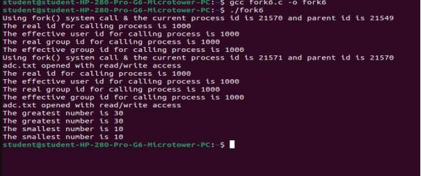

**Conclusion:** System calls are an important API for user space code to execute privileged kernel actions. Calling a system call from user space involves adding the correct arguments to registers, and trapping into the kernel. Normally this is taken care of by functions in the C library.

| Experiment No.6 |
| --- |
| Implement process scheduling algorithms FCFS and SJF using CPU-OS Simulator. |
| Date of Performance: 13/02/24 |
| Date of Submission: 20/02/24 |

**Aim:**  To study and implement process scheduling algorithms FCFS and SJF using CPU-OS Simulator.

**Objective:** Its main objective is to increase CPU utilization and hence the throughput of the system by keeping the CPU as busy as possible.

**Theory**:

A Process Scheduler schedules different processes to be assigned to the CPU based on particular scheduling algorithms.

These algorithms are either non-preemptive or preemptive. Non-preemptive algorithms are designed so that once a process enters the running state, it cannot be preempted until it completes its allotted time, whereas the preemptive scheduling is based on priority where a scheduler may preempt a low priority running process anytime when a high priority process enters into a ready state.

**First Come First Serve (FCFS)**

Jobs are executed on first come, first serve basis. It is a non-preemptive, pre-emptive scheduling algorithm. Easy to understand and implement. Its implementation is based on FIFO queue. Poor in performance as average wait time is high.

**Shortest Job First (SJF)**

This is also known as shortest job first, or SJF. This is a non-preemptive, pre-emptive scheduling algorithm. Best approach to minimize waiting time. Easy to implement in Batch systems where required CPU time is known in advance. Impossible to implement in interactive systems where required CPU time is not known. The processer should know in advance how much time process will take.

Installation steps of CPU-OS simulator:

* Go to [http://www.teach-sim.com HYPERLINK "http://www.teach-sim.com/"/](http://www.teach-sim.com/). Select downloads and get the latest version of the simulator. Install the simulator using the downloaded executable file. It will install the CPU-OS Simulator on your system.
* Or you can install it from cpu-os-simulator.software.informer.com website.
* Open the compiler window by selecting the **COMPILER** button in the current window. You should now be looking at the compiler window.

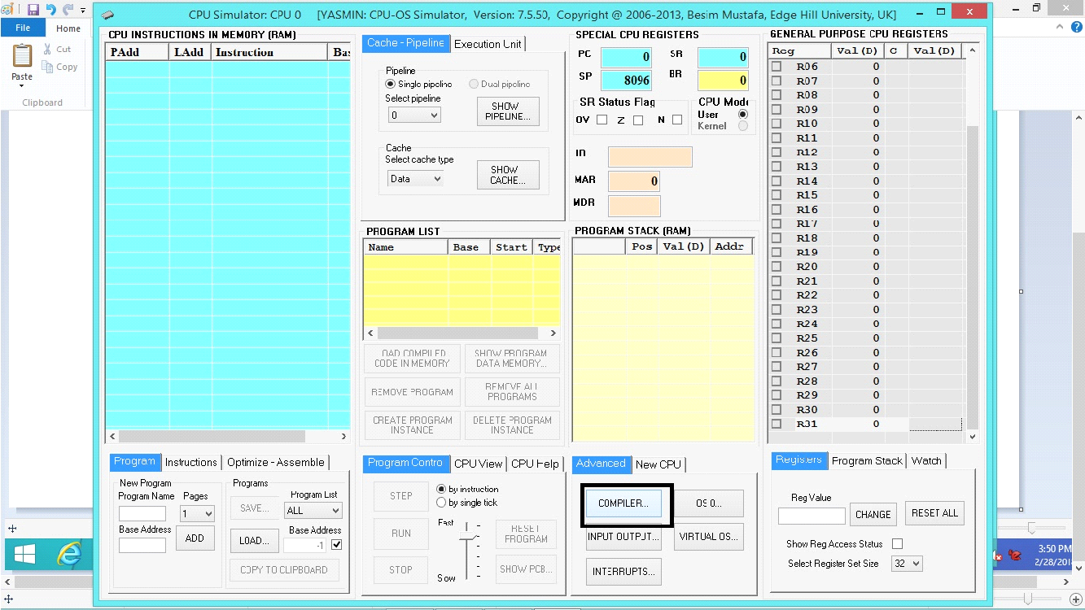

* In the compiler window, enter the following source code in the compiler’s source editor window (under PROGRAM SOURCE frame title):

PROGRAM LoopTest

i = 0

for n = 0 to 40

i = i + 1

next

end

* Save your source code.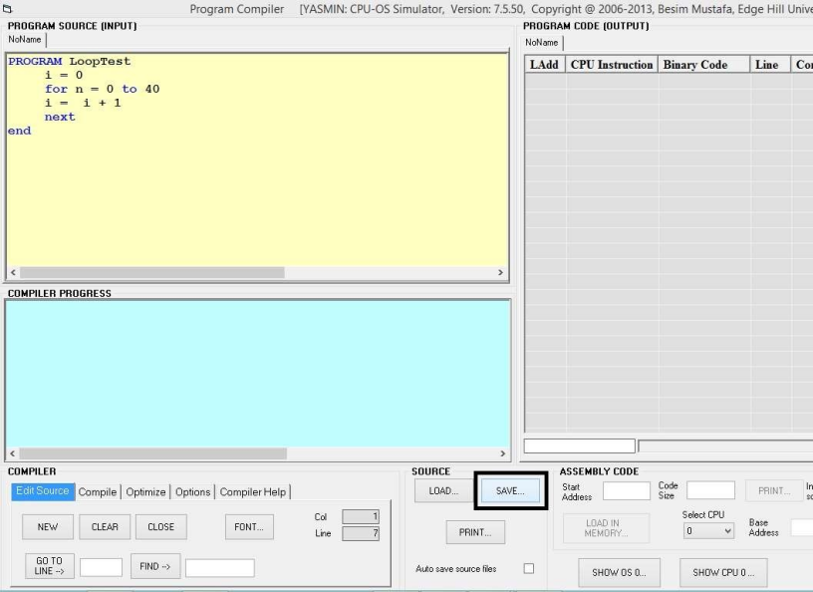
* Click on the **COMPILE** button. You should see the code created on the right in **PROGRAM CODE** view.

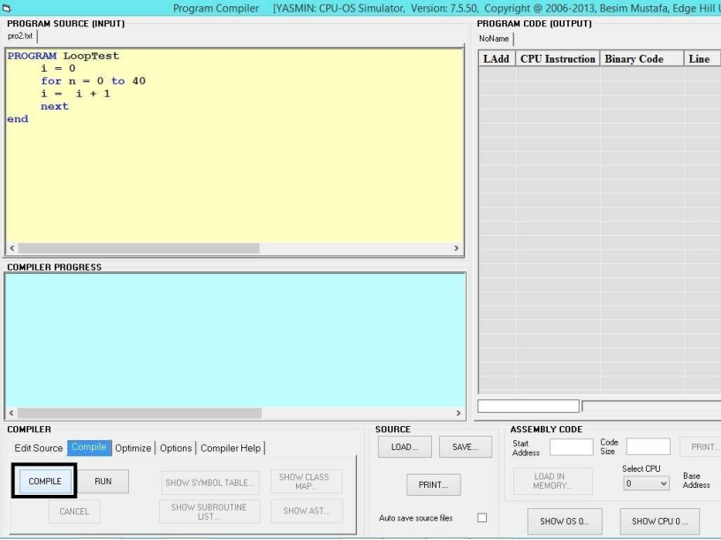

* Click on the button **SHOW** in **BINARY CODE** view. You should now see the **Hexadecimal Code for LOOPTEST** window

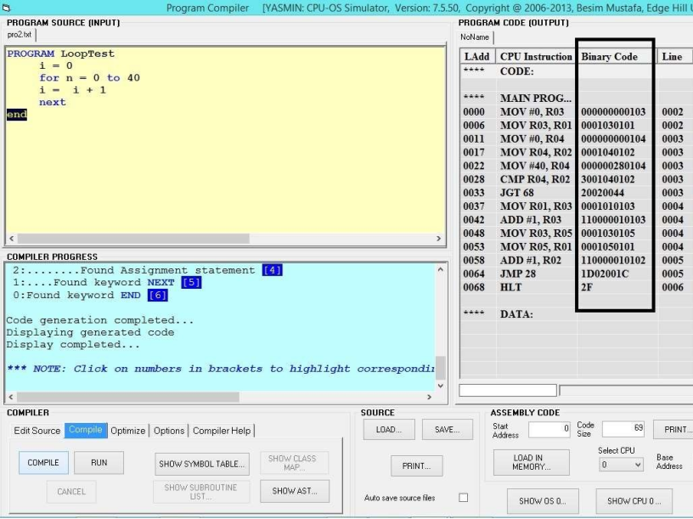

* 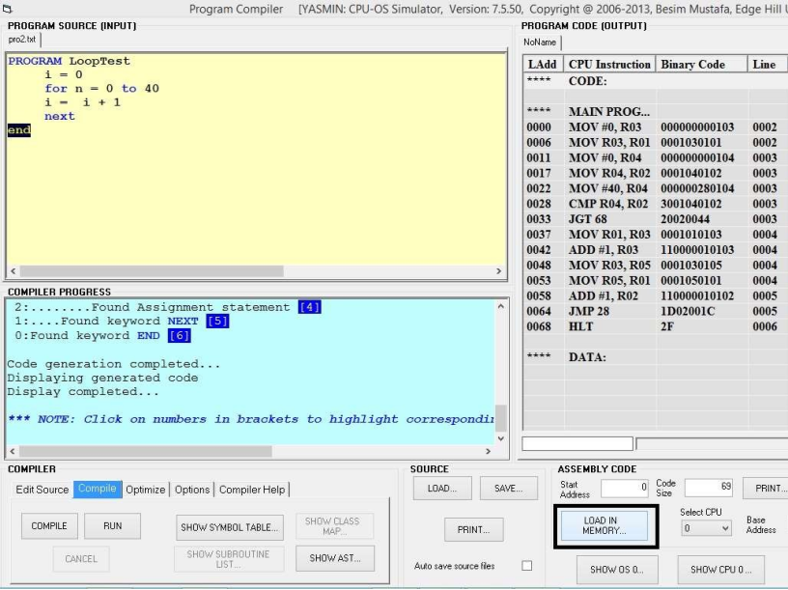Now, this code needs to be loaded in memory so that the CPU can execute it. To do this, click on the **LOAD IN MEMORY** button in the current window.
* You should now see the code loaded in memory ready to be executed. You are also back in the CPU simulator at this stage.

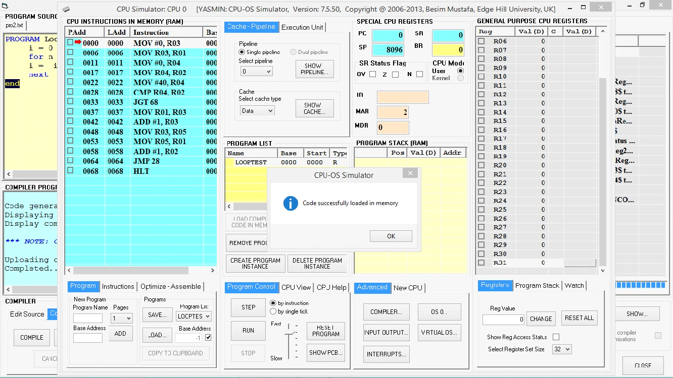

* To enter the OS simulator, click on the **OS 0** button in the current window. The OS window opens.

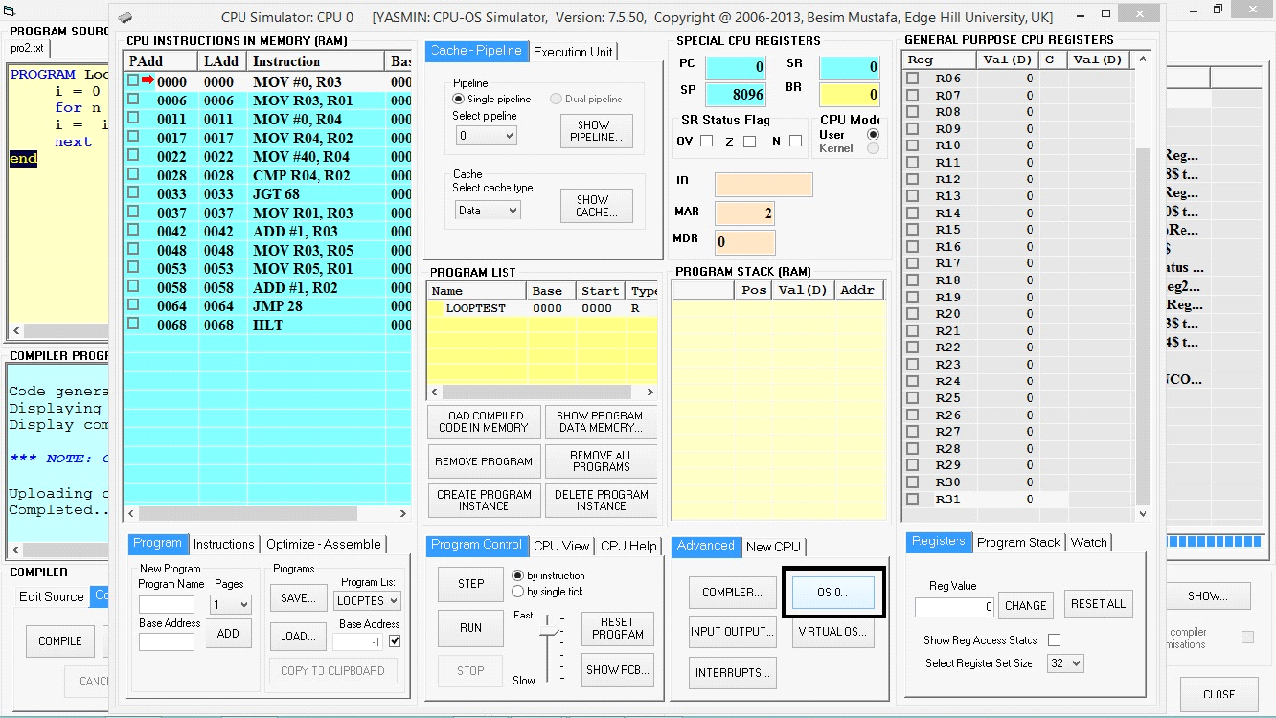

* You should see an entry, titled **LOOPTEST**, in the **PROGRAM LIST** view. Now that this program is available to the OS simulator. To create as many instances of LOOPTEST process click on **CREATE NEW PROCESS** button as shown below.

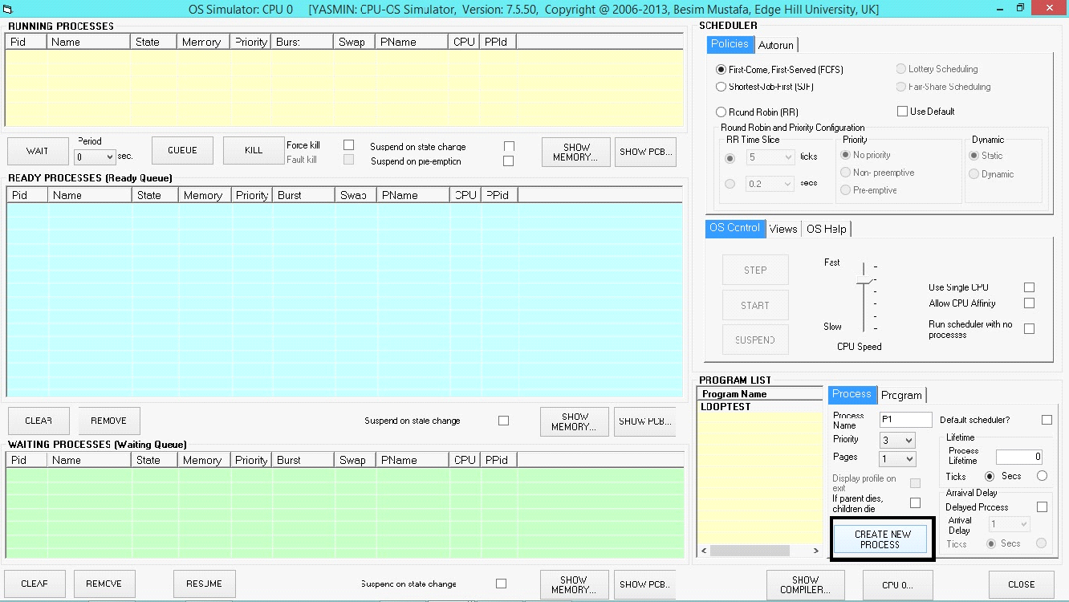

* Create 4 processes by clicking on the button 4 times. Observe the four instances of the program being queued in the ready queue which is represented by the **READY PROCESSES** view. Make sure the **First-Come-First-Served (FCFS)** option is selected in the **SCHEDULER/Policies** view. At this point the OS is inactive. To activate, first move the **Speed** slider to the fastest position, then click on the **START** button. This should start the OS simulator running the processes.

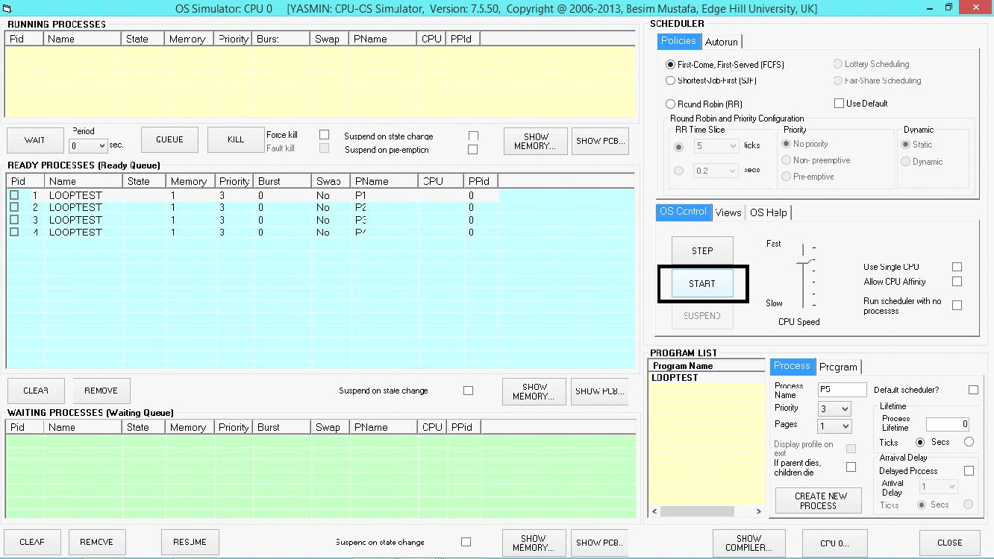

* Observe the instructions executing in the CPU simulator window. Observe the processes are running which you can see from two views that are **RUNNING PROCESSES** and **READY PROCESSES**

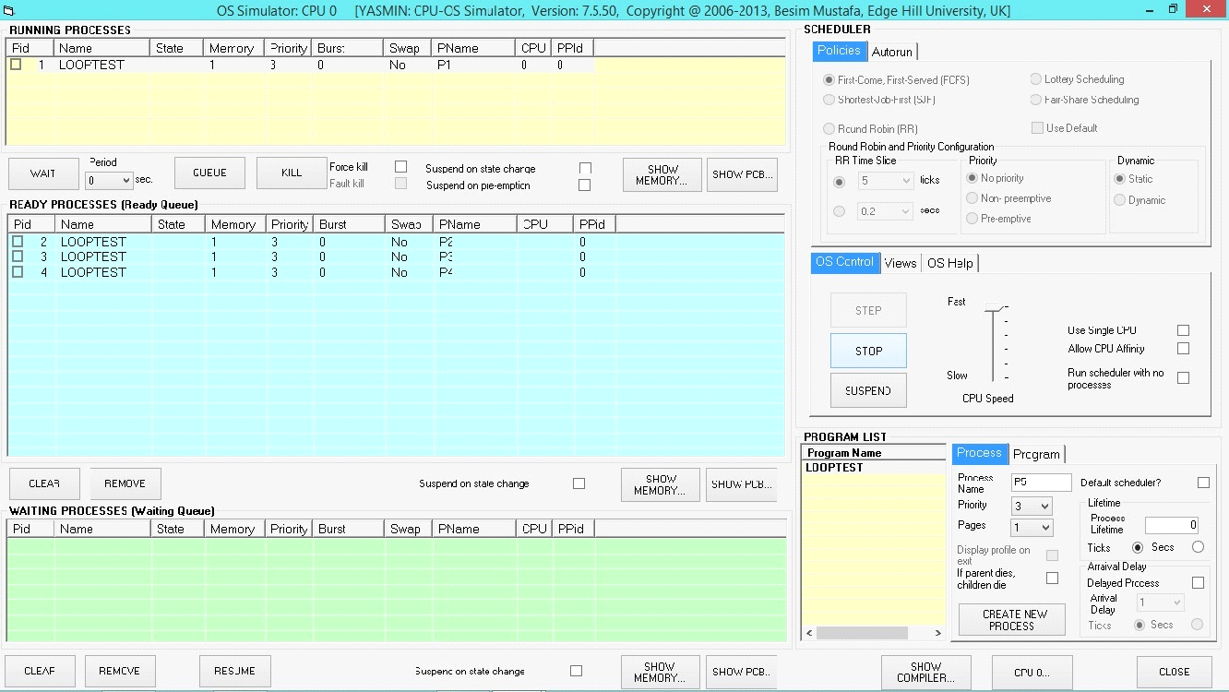

* Now, Figure out the average waiting time using the simulator.

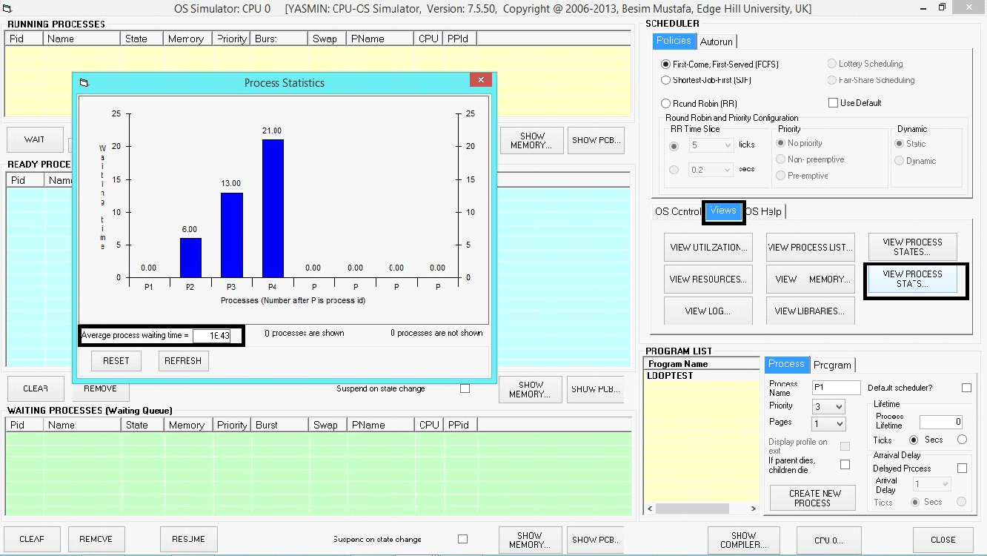

**Output:**

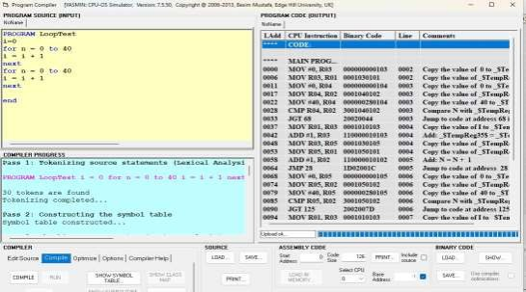

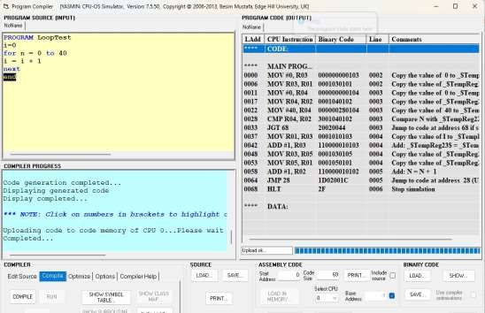

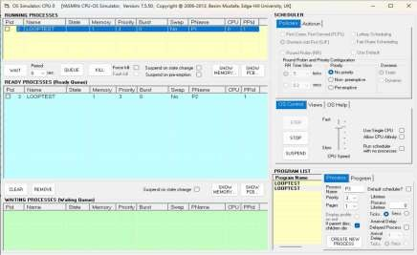

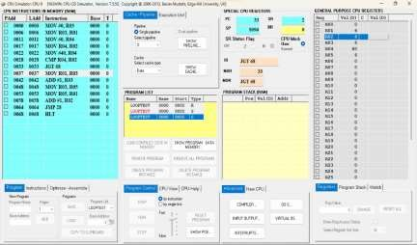

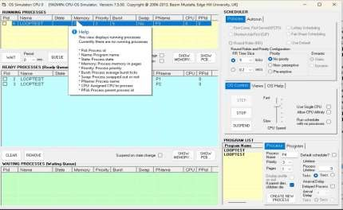

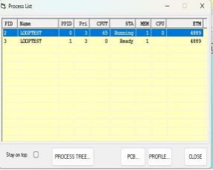

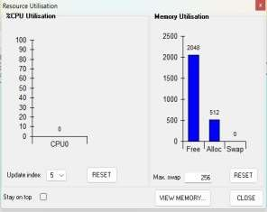

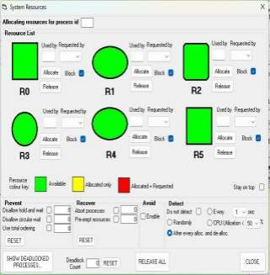

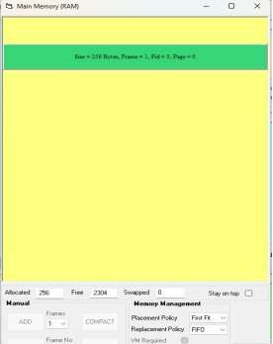

**Conclusion:** In conclusion, the CPU-OS simulator for process scheduling algorithms provides a valuable platform for studying, testing, and optimizing various scheduling strategies. It enables researchers and practitioners to analyze the performance of algorithms in a controlled environment, facilitating informed decision-making and driving innovation in operating system design.

| Experiment No.7 |
| --- |
| Implement deadlock detection and avoidance using Banker’s algorithm. |
| Date of Performance: 20/02/24 |
| Date of Submission: 27/02/24 |

**Aim:**  To study and implement deadlock detection and avoidance using Banker’s algorithm.

**Objective:** The banker’s algorithm is a resource allocation and deadlock avoidance algorithm that tests for safety by simulating the allocation for predetermined maximum possible amounts of all resources, then makes an “s-state” check to test for possible activities, before deciding whether allocation should be allowed to continue.

**Theory:**

**Data Structures for the Banker’s Algorithm.**

Let n = number of processes, and m = number of resources types.

1. Available: Vector of length m. If available [j] = k, there are k instances of resource type Rj available

2.Max: n x m matrix.

If Max [i,j] = k, then process Pi may request at most k instances of resource type Rj

3. Allocation: n x m matrix. If Allocation[i,j] = k then Pi is currently allocated k instances of Rj

4.Need: n x m matrix. If Need[i,j] = k, then Pi may need k more instances of Rj to complete its task

Need [i,j] = Max[i,j] – Allocation [i,j]

**Safety Algorithm**

* Let Work and Finish be vectors of length m and n, respectively.

Initialize:

Work = Available

Finish [i] = false for i = 0, 1, …, n- 1

* Find an i such that both:
* Finish [i] = false
* Needi Work

If no such i exists, go to step 4

* Work = Work + Allocationi

Finish[i] = true

go to step 2

* If Finish [i] == true for all i, then the system is in a safe state.

**Resource-Request Algorithm for Process Pi**

Request i = request vector for process Pi . If Requesti [j] = k then process Pi wants k instances of resource type Rj

1. If Requesti Needi go to step 2. Otherwise, raise error condition, since process has exceeded its maximum claim

2. If Requesti Available, go to step 3. Otherwise Pi must wait, since resources are not available 3. Pretend to allocate requested resources to Pi by modifying the state as follows:

Available = Available – Requesti ;

Allocationi = Allocationi + Requesti ;

Needi = Needi – Requesti ;

1.If safe the resources are allocated to Pi

2. If unsafe Pi must wait, and the old resource-allocation state is restored.

**Code:**

**#include <stdio.h>**

**int main()**

**{**

**int n, m, i, j, k;**

**n = 5;**

**m = 3;**

**int alloc[5][3] = {{0, 1, 0},**

**{2, 0, 0},**

**{3, 0, 2},**

**{2, 1, 1},**

**{0, 0, 2}};**

**int max[5][3] = {{7, 5, 3},**

**{3, 2, 2},**

**{9, 0, 2},**

**{2, 2, 2},**

**{4, 3, 3}};**

**int avail[3] = {3, 3, 2};**

**int f[n], ans[n], ind = 0;**

**for (k = 0; k < n; k++)**

**{**

**f[k] = 0;**

**}**

**int need[n][m];**

**for (i = 0; i < n; i++)**

**{**

**for (j = 0; j < m; j++)**

**need[i][j] = max[i][j] - alloc[i][j];**

**}**

**int y = 0;**

**for (k = 0; k < 5; k++)**

**{**

**for (i = 0; i < n; i++)**

**{**

**if (f[i] == 0)**

**{**

**int flag = 0;**

**for (j = 0; j < m; j++)**

**{**

**if (need[i][j] > avail[j])**

**{**

**flag = 1;**

**break;**

**}**

**}**

**if (flag == 0)**

**{**

**ans[ind++] = i;**

**for (y = 0; y < m; y++)**

**avail[y] += alloc[i][y];**

**f[i] = 1;**

**}**

**}**

**}**

**}**

**int flag = 1;**

**for (i = 0; i < n; i++)**

**{**

**if (f[i] == 0)**

**{**

**flag = 0;**

**printf("The following system is not safe");**

**break;**

**}**

**}**

**if (flag == 1)**

**{**

**printf("Following is the SAFE Sequence\n");**

**for (i = 0; i < n - 1; i++)**

**printf(" P%d ->", ans[i]);**

**printf(" P%d", ans[n - 1]);**

**}**

**return (0);**

**}**

**Output:**

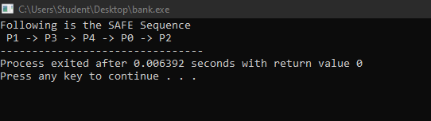

**Conclusion:**  The code initializes the necessary variables such as the number of processes (n), the number of resource types (m), allocation matrix (alloc), maximum matrix (max), and available resources (avail).The code initializes the necessary variables such as the number of processes (n), the number of resource types (m), allocation matrix (alloc), maximum matrix (max), and available resources (avail).The code effectively demonstrates the Banker's algorithm for deadlock avoidance by determining a safe execution sequence of processes based on the available resources and maximum resource requirements. However, it assumes fixed resource allocation and does not include provisions for dynamic resource requests during execution.

| Experiment No.8 |
| --- |
| Implement memory allocation strategy First fit. |
| Date of Performance: 27/02/24 |
| Date of Submission: 05/04/24 |

**Aim:**  To study and implement memory allocation strategy First fit.

**Objective:** The objective of memory allocation strategies  is to provide ways to dynamically allocate portions of memory to programs at their request, and free it for reuse when no longer needed as the main memory is limited in size.

**Theory:**

The primary role of the memory management system is to satisfy requests for memory allocation. Sometimes this is implicit, as when a new process is created. At other times, processes explicitly request memory. Either way, the system must locate enough unallocated memory and assign it to the process.

**Partitioning:** The simplest methods of allocating memory are based on dividing memory into areas with fixed partitions.

**Selection Policies:** If more than one free block can satisfy a request, then which one should we pick? There are several schemes that are frequently studied and are commonly used.

**First Fit:** In the first fit approach is to allocate the first free partition or hole large enough which can accommodate the process. It finishes after finding the first suitable free partition.

* **Advantage:** Fastest algorithm because it searches as little as possible.
* **Disadvantage:** The remaining unused memory areas left after allocation become waste if it is too smaller. Thus request for larger memory requirement cannot be accomplished.

**Best Fit:** The best fit deals with allocating the smallest free partition which meets the requirement of the requesting process. This algorithm first searches the entire list of free partitions and considers the smallest hole that is adequate. It then tries to find a hole which is close to actual process size needed.

**Worst fit:** In worst fit approach is to locate largest available free portion so that the portion left will be big enough to be useful. It is the reverse of best fit.

Next Fit: If we want to spread the allocations out more evenly across the memory space, we often use a policy called next fit. This scheme is very similar to the first fit approach, except for the place where the search starts.

**Code:**

**#include<stdio.h>**

**void main()**

**{**

**int bsize[10], psize[10], bno, pno, flags[10], allocation[10], i, j;**

**for(i = 0; i < 10; i++)**

**{**

**flags[i] = 0;**

**allocation[i] = -1;**

**}**

**printf("Enter no. of blocks: ");**

**scanf("%d", &bno);**

**printf("\nEnter size of each block: ");**

**for(i = 0; i < bno; i++)**

**scanf("%d", &bsize[i]);**

**printf("\nEnter no. of processes: ");**

**scanf("%d", &pno);**

**printf("\nEnter size of each process: ");**

**for(i = 0; i < pno; i++)**

**scanf("%d", &psize[i]);**

**for(i = 0; i < pno; i++)**

**for(j = 0; j < bno; j++)**

**if(flags[j] == 0 && bsize[j] >= psize[i])**

**{**

**allocation[j] = i;**

**flags[j] = 1;**

**break;**

**}**

**printf("\nBlock no.\tsize\t\tprocess no.\t\tsize");**

**for(i = 0; i < bno; i++)**

**{**

**printf("\n%d\t\t%d\t\t", i+1, bsize[i]);**

**if(flags[i] == 1)**

**printf("%d\t\t\t%d",allocation[i]+1,psize[allocation[i]]);**

**else**

**printf("Not allocated");**

**}**

**}**

**Output:**

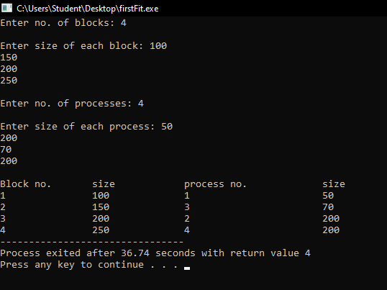

**Conclusion:** The code initializes arrays to store block sizes, process sizes, allocation flags, and allocation information.It takes input from the user for the number of memory blocks (bno), their sizes (bsize), the number of processes (pno), and their sizes (psize).It iterates through each process and each memory block to find the first block that is both unallocated (flags[j] == 0) and large enough to accommodate the process (bsize[j] >= psize[i]). Once such a block is found, it marks it as allocated (flags[j] = 1) and records the allocation.It displays the allocation information, including the block number, its size, and the process allocated to it. If a block is not allocated to any process, it indicates that it's not allocated.The code demonstrates the First Fit memory allocation strategy effectively by allocating memory blocks to processes based on the first block that fits the process size. However, it does not handle cases where fragmentation might occur, potentially leading to inefficient memory utilization. Additionally, it assumes fixed memory block and process sizes, which may not reflect real-world scenarios where sizes vary dynamically.

| Experiment No.9 |
| --- |
| Implement page replacement policy FIFO. |
| Date of Performance: 05/04/24 |
| Date of Submission: 12/04/24 |

**Aim:**  To study and implement page replacement policy FIFO.

**Objective:** Page replacement algorithms are an important part of virtual memory management and it helps the OS to decide which memory page can be moved out, making space for the currently needed page. However, the ultimate objective of all page replacement algorithms is to reduce the number of page faults.

**Theory:**

**Demand Paging**

A demand paging system is quite similar to a paging system with swapping where processes reside in secondary memory and pages are loaded only on demand, not in advance. When a context switch occurs, the operating system does not copy any of the old program’s pages out to the disk or any of the new program’s pages into the main memory Instead, it just begins executing the new program after loading the first page and fetches that program’s pages as they are referenced.

**Page Replacement Algorithm**

Page replacement algorithms are the techniques using which an Operating System decides which memory pages to swap out, write to disk when a page of memory needs to be allocated.

**Reference String**

The string of memory references is called reference string. Reference strings are generated artificially or by tracing a given system and recording the address of each memory reference.

**First In First Out (FIFO) algorithm**

The page which has been loaded first in the main memory is selected first for replacement from the main memory.

**Code:**

#include <stdio.h>

int main()

{

int incomingStream[]={3,1,4,5,2};

int pageFaults=0;

int frames=3;

int m,n,s,pages;

pages=sizeof(incomingStream)/sizeof(incomingStream[0]);

printf("Incoming\t Frame1 \t Frame2 \t Frame3");

int temp[frames];

for(m=0;m<frames;m++)

{

temp[m]=-1;

}

for(n=0;n<frames;n++)

{

s=0;

for(n=0;n<frames;n++)

{

if(incomingStream[m]==temp[n])

{

s++;

pageFaults;

}

}

pageFaults++;

if((pageFaults<-frames) && (s==0))

{

temp[m]=incomingStream[m];

}

else if(s==0)

{

temp[(pageFaults-1)%frames]=incomingStream[m];

}

printf("\n");

printf("%d\t\t\t",incomingStream[m]);

for(n=0;n<frames;n++)

{

if(temp[n]!=-1)

printf("%d\t\t\t",temp[n]);

else

printf("-\t\t\t");

}

}

printf("\n Total Page Faults:\t %d \n",pageFaults);

return 0;

}

**Output:**

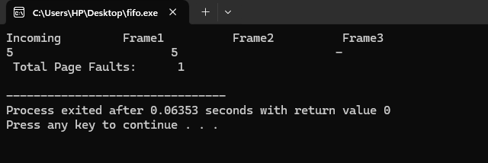

**Conclusion: ·** FIFO page replacement algorithm in os is responsible for keeping track of all the pages in a queue. FIFO page replacement algorithm is a good choice When the number of incoming pages is few. Otherwise, It’s not the best replacement algorithm to use practically.

| Experiment No.10 |
| --- |
| Implement disk scheduling algorithms SCAN. |
| Date of Performance: 12/04/24 |
| Date of Submission: 18/04/24 |

**Aim:**  To study and implement disk scheduling algorithms SCAN

**Objective:** The main purpose of disk scheduling algorithm is to select a disk request from the queue of IO requests and decide the schedule when this request will be processed.

**Theory:**

SCAN(Elevator)  
In the SCAN Disk Scheduling Algorithm, the head starts from one end of the disk and moves towards the other end, servicing requests in between one by one and reaching the other end. Then the direction of the head is reversed and the process continues as the head continuously scans back and forth to access the disk. So, this algorithm works as an elevator and is hence also known as the elevator algorithm. As a result, the requests at the midrange are serviced more and those arriving behind the disk arm will have to wait.

*Algorithm*

Step 1:Let the Request array represents an array storing indexes of tracks that have been requested in ascending order of their time of arrival. ‘head’ is the position of the disk head.

Step 2:Let direction represents whether the head is moving towards left or right.

Step 3: In the direction in which the head is moving, service all tracks one by one.

Step 4: Calculate the absolute distance of the track from the head.

Step 5: Increment the total seek count with this distance.

Step 6: Currently serviced track position now becomes the new head position.

Step 7: Go to step 3 until we reach one of the ends of the disk.

Step 8: If we reach the end of the disk reverse the direction and go to step 2 until all tracks in the request array have not been serviced.

**Code:**

#include <stdio.h>

#include <stdlib.h>

#define MAX_REQUESTS 100

// Function to sort an array

void sort(int arr[], int n) {

for (int i = 0; i < n-1; i++) {

for (int j = 0; j < n-i-1; j++) {

if (arr[j] > arr[j+1]) {

int temp = arr[j];

arr[j] = arr[j+1];

arr[j+1] = temp;

}

}

}

}

int scan_disk(int head_position, int requests[], int num_requests, char direction, int disk_size) {

int total_movement = 0;

int current_position = head_position;

int *sorted_requests = (int *)malloc((num_requests + 1) * sizeof(int));

for (int i = 0; i < num_requests; i++) {

sorted_requests[i] = requests[i];

}

sort(sorted_requests, num_requests);

if (direction == 'R') {

sorted_requests[num_requests] = disk_size - 1;

} else {

sorted_requests[num_requests] = 0;

}

int next_request;

while (1) {

if (direction == 'R') {

next_request = -1;

for (int i = 0; i <= num_requests; i++) {

if (sorted_requests[i] >= current_position) {

next_request = sorted_requests[i];

break;

}

}

if (next_request == -1) {

break;

}

} else {

next_request = -1;

for (int i = num_requests; i >= 0; i--) {

if (sorted_requests[i] <= current_position) {

next_request = sorted_requests[i];

break;

}

}

if (next_request == -1) {

break;

}

}

total_movement += abs(next_request - current_position);

current_position = next_request;

for (int i = 0; i <= num_requests; i++) {

if (sorted_requests[i] == next_request) {

for (int j = i; j < num_requests; j++) {

sorted_requests[j] = sorted_requests[j+1];

}

break;

}

}

if ((direction == 'R' && current_position == disk_size - 1) || (direction == 'L' && current_position == 0)) {

direction = (direction == 'R') ? 'L' : 'R';

}

}

free(sorted_requests);

return total_movement;

}

int main() {

int head_position;

int requests[MAX_REQUESTS];

int num_requests;

int disk_size;

char direction;

printf("Enter the head position: ");

scanf("%d", &head_position);

printf("Enter the number of requests: ");

scanf("%d", &num_requests);

printf("Enter the requests: ");

for (int i = 0; i < num_requests; i++) {

scanf("%d", &requests[i]);

}

printf("Enter the disk size: ");

scanf("%d", &disk_size);

printf("Enter the direction (R for right, L for left): ");

scanf(" %c", &direction);

int total_movement = scan_disk(head_position, requests, num_requests, direction, disk_size);

printf("Total movement: %d\n", total_movement);

return 0;

}

**Output:**

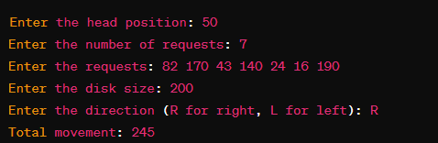

**Conclusion:** SCAN disk scheduling starts at one end, servicing requests along the way, and reverses direction. C SCAN disk scheduling adds predictability by ignoring requests while returning, reducing variability in waiting times. These algorithms are efficient, ensuring all requests eventually get served.